**30.283 Dramatic Literature in Canada**

Fall 2017

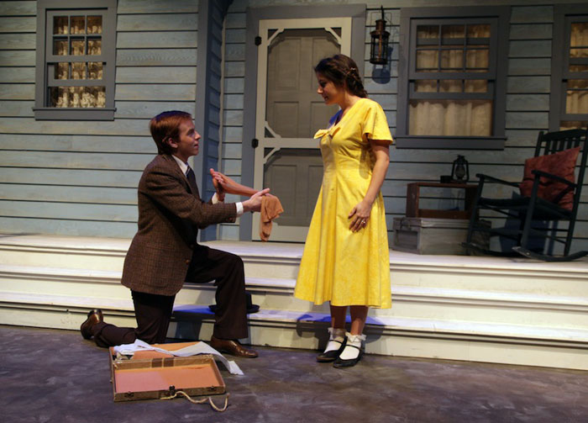

**Instructor:** Dr. Reinhold Kramer

109 Original Building/Clark Hall

727-7344 kramer@brandonu.ca

Office: 2:40-3:30 p.m. Mon, Tues, Wed

Webpages: google “Reinhold Kramer”

or <http://people.brandonu.ca/kramer/>

**Course Description:**

An examination of the origins and development

of Canadian drama, and an analysis of Canadian plays, particularly those from 1960 to the present. The course may include plays by writers such as Andrea Pittman & Gavin Opp, Powerhouse, Vernon, 2015

Michel Tremblay, David French, Michael Cook, Joan

MacLeod, George F. Walker, Margaret Hollingsworth, Kelly Rebar, and Ian Ross.

**Assignments:**

1. Class participation 10%

2. Play response **19 Sept.** 5%

3. Test **10 Oct.** 20%

4. Term Paper (10-12 pages) **due 21 Nov.**  25%

5. Final Exam **12 Dec.** **2-4 p.m.** 40%

There may be penalties for lateness, depending upon circumstances. Missed tests cannot be rewritten without a doctor’s note or other documentation. Cite all sources for ideas and quotations. Assignments containing plagiarism will be graded “0” and will result in disciplinary action. Please read BU *General Calendar* section 3.13 “Academic Dishonesty,” and *Writing English*, p. 420-8. No cell phones or laptops in class.

For the very shy: in place of “class participation” you may hand in, 5 times during the course, short (1-page, double-spaced, typed) analyses, not plot summaries, of the play under discussion that day. These commentaries must be handed in *before* the play is discussed in class and are worth 2% each. No commentaries will be accepted after class discussions for *any* reason.

Students who require accommodations for permanent, chronic, or temporary disabilitiesshould contact Student Accessibility Services (204-727-9759 or [malyonm@brandonu.ca](mailto:malyonm@brandonu.ca)). Student Services also offers personal counselling (contact 204-727-9737). Students may find controversial readings and/or discussions troubling. If so, please contact me immediately for alternatives.

**Grading: Letter/Number/Grade Point**

Outstanding Good Satisfactory Weak Inadequate

A+ 90 & up 4.3 B+ 77-79 3.3 C+ 67-69 2.3 D 50-59 1.0 F 0-49 0

A 84-89 4.0 B 74-76 3.0 C 64-66 2.0

A- 80-83 3.7 B- 70-73 2.7 C- 60-63 1.7

**Texts:**

Cook, Michael. *Jacob’s Wake*.

French, David. *Saltwater Moon*.

Hollingsworth, Margaret*. Ever Loving* and *The Apple in the Eye* in *Willful Acts*.

Lakevold, Dale. *Notes Towards a Speech Re: My Ex-*.

MacLeod, Joan. *The Valley*.

Messenger, William, et. al. *Writing English: The Canadian Handbook*.

Mighton, John. *A Short History of Night* in *Possible Worlds & A Short History of Night*.

Panych, Morris. *Benevolence*.

Ross, Ian. *FareWel*.

Tremblay, Michel. *Les Belles Soeurs*.

**Schedule:**

Sept. 7 Introduction to Canadian Theatre

Sept. 12 - 14 Tremblay, *Les Belles Soeurs* (1968)

Sept. 19 - 26 Cook, *Jacob’s Wake* (1975)

Sept. 19 Play response (in-class)

Sept. 28 - Oct. 5 Hollingsworth, *Ever Loving* (1981), *The Apple in the Eye* (1983)

Oct.10 **Test**

Oct. 12 - 17 French, *Saltwater Moon* (1985)

Oct. 19 - 26 Mighton, *A Short History of Night* (1990)

Oct. 31 - Nov. 1 Lakevold, *Notes Towards a Speech Re: My Ex-* (2001)

Nov. 6 - 10 Fall break – no classes

Nov. 14 - 16 Ross. *FareWel* (1996)

Nov. 21 **Term Paper due**

Nov. 21 -28 Panych, *Benevolence* (2007)

Nov. 30 - Dec. 5 MacLeod, *The Valley* (2013)

Review

**Dec. 12 Final Exam Tues., 2-4 p.m.**