30.386 History of Literary Criticism
Fall 2021
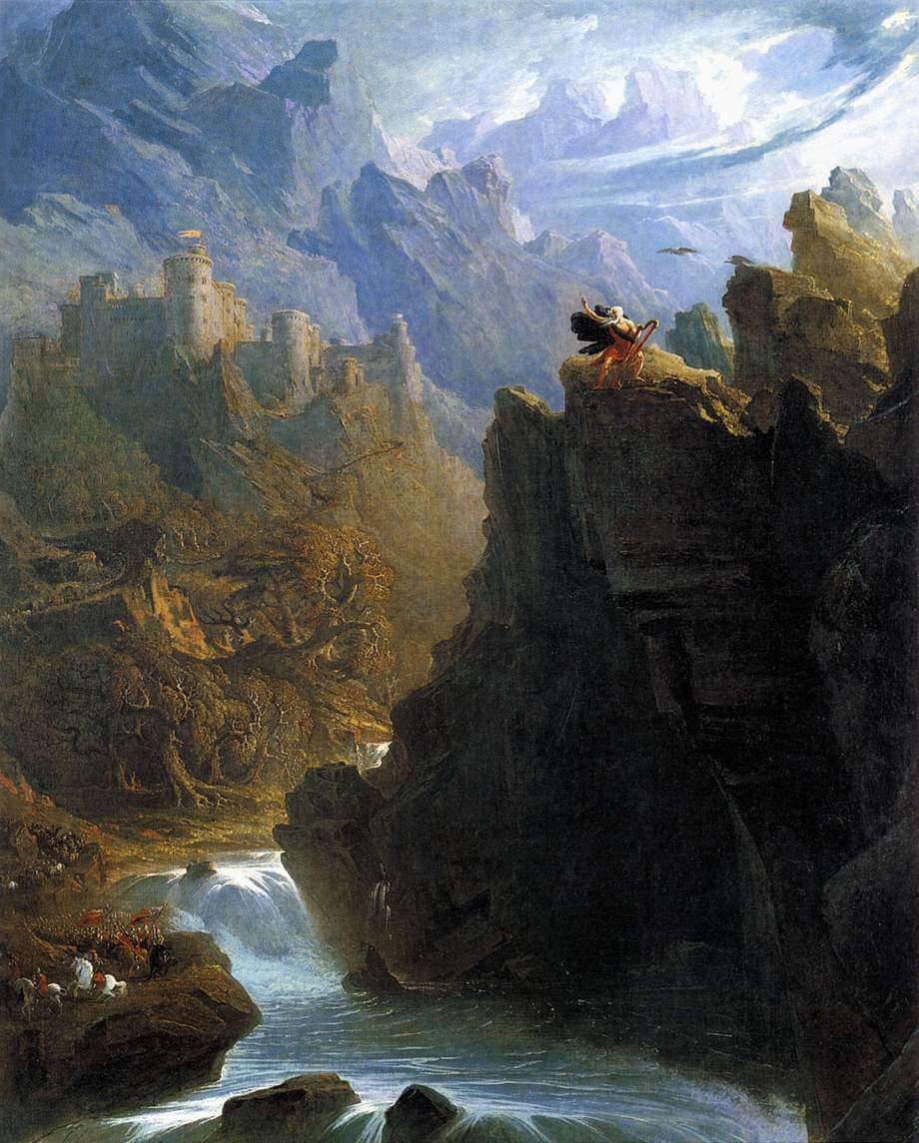
Instructor: Dr. Reinhold Kramer
109 Clark Hall 727-7344
kramer@brandonu.ca
Office: 2:40-3:30 (Mon, Wed), 1:30-2:30 (Thur)
Home page: google “Reinhold Kramer”
or http://people.brandonu.ca/kramer/

Course Description: A survey of Western literary theory, especially thought about aesthetics and signification, from the 6th Century B.C. to the beginning of the 20th Century. The course will focus on the strengths and weaknesses of selected theories that informed the writing and reading of literature during various literary periods. Emphasis will fall on the historical context for each theorist, but we will also de-contextualize: finding where seemingly superseded theories still address contemporary concerns. John Martin, “The Bard”

Assignments:
- Class Participation 10%
- Reading Tests (on whole books) 22, 24 September 10%
- Mid-term Test 22 October 20%
- Essay (12-14 pages) 22 November 20%
- Final Exam Dec. 20, 9-11 a.m. 40%

There may be penalties for lateness, depending upon circumstances. Reading tests cannot be postponed, and missed tests require a doctor’s note or other documentation. Cite all sources for ideas and quotations. Assignments containing plagiarism will be graded “0” and will result in disciplinary action. Please read BU Calendar 3.14 “Academic Integrity” and Messenger p. 420-8. No cell phones in class. No laptops, unless required through Student Accessibility Services.

For the very shy: in place of “class participation,” you may hand in, up to 5 times during the course, short (1-page, double-spaced, typed) analyses, not plot summaries, of a portion of the work under discussion that day. These analyses must be handed in before the work is discussed in class and are worth 2% each. No analyses will be accepted after class discussions for any reason.

Students who require disability accommodations should register with the Accessibility Services Coordinator, 204-727-9759, magnussonm@brandonu.ca. Student Services also offers personal counselling (contact 204-727-9737). If students find controversial readings and/or discussions troubling, please contact the instructor immediately about alternatives.

Grading: Letter/Number/Grade Point
Outstanding Good Satisfactory Weak Inadequate
A+ 90 & up 4.3 B+ 77-79 3.3 C+ 67-69 2.3 D 50-59 1.0 F 0-49 0
A 85-89 4.0 B 73-76 3.0 C 63-66 2.0
A- 80-84 3.7 B- 70-72 2.7 C- 60-62 1.7

Texts:

Leitch, Vincent B. et. al. The Norton Anthology of Theory and Criticism 3rd edition. Norton.
Messenger, William, et. al. Writing English: The Canadian Handbook. (optional)
Plato. The Symposium. Penguin.
Shakespeare. King Lear. New American Library.

Schedule: Sept. 8-10 Introduction: theory’s reason

Classical
Sept. 13 Gorgias of Leontini, from Encomium of Helen, pp. 40-42
15 Plato, Ion, pp. 46-58
17 - 20 Plato, from The Republic Book X, pp. 78-89
22 King Lear *(bring to every class, as a test case for the value of the theories)
24 - 29 Plato, The Symposium
Oct. 1 - 6 Aristotle, Poetics, pp. 99-117 (up to #21), 121-7 (#23 to end)
Oct. 8 Horace, Ars Poetica, pp. 133-44
13, 15 Longinus, from On Sublimity, pp. 146-64

Medieval
18 - 20 Augustine, from On Christian Doctrine, pp. 166-77 & photocopy
22 Mid-term Test
25 - 27 Maimonides, from The Guide of the Perplexed, pp.184-8,
Dante, from The Letter to Can Grande della Scala, pp. 198-9

Renaissance
Oct. 29 - Nov. 3 Sidney, The Defence of Poesy, pp. 262-91

Enlightenment
Nov. 5 Dryden, from An Essay of Dramatic Poesy, pp. 308-10
8-12 Fall break (no classes)
15 Behn, “Epistle to the Reader,” The Dutch Lover, pp. 329-34
“Preface,” The Lucky Chance, pp. 334-7
17 Johnson, from Rasselas; from Preface to Shakespeare, pp. 390-405
19 - 22 Kant, from Critique of Judgement, pp. 429-36, 439-41, 445-7, 451-4
(Intro, §1-7, §13-14, §23, §27-8)
22 Essay due

Romanticism
24 - 26 Wordsworth, “Preface to Second Edition,” Lyrical Ballads, pp. 566-86
Nov. 29 - Dec. 1 Coleridge, from Biographia Literaria, pp. 590-7

Humanism
Dec. 3 - 8 Arnold, The Function of Criticism at the Present Time, pp. 684-703
“Sweetness & Light,” pp. 703-10
Dec. 8 Review
Dec. 20, 9-11 a.m. Final Exam (in-person)
STATEMENT ON RESPONSIBILITIES OF STUDENTS FOR IN PERSON INSTRUCTION DURING COVID-19
Brandon University values the health and safety of its students and employees. Our shared goal during the COVID-19 pandemic is to create learning environments that are safe. In providing in-person course instruction, Brandon University considered how best to decrease the spread of COVID-19 and lessen the impact in your learning environment. Physical campus enhancements as well as health and safety protocols have been implemented to reduce COVID- 19 transmission amongst instructors and students. These protocols are in place to maintain a safe work environment so as to not interrupt your studies. In registering for this in-person course, students are asked to respect the health and safety of their peers, the instructor and other Brandon University employees by adhering to the posted COVID-19 health and safety guidelines at all times during instruction of this course. Failure to do so may put others at risk and could result in your removal from in person instruction and/or the building itself (Student-Non- Academic-Misconduct-Policy-July-2020-.pdf). Additional information on COVID-19 is available on the Brandon University website (https://www.brandonu.ca/covid-19/).

*In the event that courses are forced to go online, all students please go to https://www.brandonu.ca/helpdesk/students/im-a-new-student/ms-teams-at-brandon-university/ to get onboard with MS Teams. Contact the HelpDesk (helpdesk@brandonu.ca or 571-8500) if you have questions. In that case, tests and exams will take place in an MS Teams meeting.

