30.387 Alternate Worlds
Winter 2022

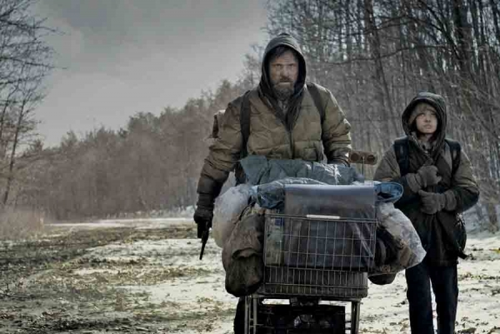
Instructor: Dr. Reinhold Kramer
109 Original Building/Clark Hall
727-7344 kramer@brandonu.ca
Office: 2:40-3:30 p.m. Mon, Wed, Fri
Webpages: google “Reinhold Kramer”
or http://people.brandonu.ca/kramer/

Course Description: We will examine a rich series of ‘scenario-spinning’ works, in which authors create worlds that are neither completely fantastic nor fully representative of our own world. Fiction to be studied could include Mitchell, Cloud Atlas; McCarthy, The Road; Scene from The Road (2009)
Chabon, The Yiddish Policemen’s Union; Vonarburg, The
Maerlande Chronicles. Films could include Wenders & Handke, Wings of Desire (Der Himmel über Berlin) and Jeunet & Laurant, Amélie (Le Fabuleux destin d’Amélie Poulain). Titles may change with little notice.

Assignments: 1. Class Participation 10%
2. Reading Tests Jan. 18, 25; Feb. 15, Mar. 3, 22; Apr. 5 10%
3 Mid-term Test 17 February 20%
4. Essay (10-12 pages) 29 March 20%
5. Final Exam April 22 (Friday) 2-4 p.m. 40%

There may be penalties for lateness, depending upon circumstances. Reading tests cannot be postponed, and missed tests cannot be rewritten without a doctor’s note or other documentation. Reading tests cover the entire novel. Exceptions are Cloud Atlas (for which the first reading test covers pp. 1-236 and the second test pp. 237-509), as well as The Maerlande Chronicles (for which the first reading test covers pp. 10-317 and the second test pp. 318-582). Cite all sources for ideas and quotations. Assignments containing plagiarism will be graded “0” and will result in disciplinary action. Please read BU Undergraduate Calendar 3.14 “Academic Integrity” and William Messenger p. 420-8. No cell phones in class.

For the very shy: in place of “class participation,” you may hand in, up to 5 times during the course, short (one full page, double-spaced, typed) analyses, not plot summaries or reader responses, of a portion of the work under discussion that day. These analyses, worth 2% each, must be handed in before the work is discussed in class. No analyses will be accepted after class discussions for any reason.

Students who require disability accommodations should register with the Accessibility Services Coordinator, 204-727-9759, magnussonm@brandonu.ca. Student Services also offers personal counselling (contact 204-727-9737). If students find controversial readings and/or discussions troubling, please contact the instructor immediately about alternatives.

Grading: Letter/Number/Grade Point
Outstanding Good Satisfactory Weak Inadequate
A+ 90 & up 4.3 B+ 77-79 3.3 C+ 67-69 2.3 D 50-59 1.0 F 0-49 0
A 85-89 4.0 B 73-76 3.0 C 63-66 2.0
A- 80-84 3.7 B- 70-72 2.7 C- 60-62 1.7

Texts:
Chabon, Michael. The Yiddish Policemen’s Union, HarperCollins, 2007.
McCarthy, Cormac. Vintage (Random House), The Road, 2006.
Mitchell, David. Cloud Atlas, Vintage (Random House), 2004.
Messenger, William, et. al. Writing English: The Canadian Handbook, Oxford UP, 2012. (optional)
Vonarburg, Élisabeth. The Maerlande Chronicles. Tesseract (Edge SF & Fantasy), 1992.

Schedule:
Jan. 13 Introduction

Jan. 18 - Feb. 3 Mitchell, Cloud Atlas (2004)
Jan. 18 Reading test, pp. 1-236
Jan. 25 Reading test, pp. 237-509

Feb. 8 - 10 Wim Wenders & Peter Handke, Wings of Desire
(Der Himmel über Berlin; 1987) (2:08)
*Feb. 8th class runs from 10:10 - 12:30 to view film

Feb. 15 - Mar. 10 Vonarburg, The Maerlande Chronicles (Chronique du pays des mères, 1992)
Feb. 15 Reading test, pp. 10-317
Feb. 17 Mid-term Test
Feb. 21 - 25 Study break (no classes)
Mar. 3 Reading test, pp. 318-582

Mar. 15 - 17 Jean-Pierre Jeunet & Guillaume Laurant, Amélie
(Le fabuleux destin d’Amélie Poulain; 2001) (2:02)
*Mar. 15th class runs from 10:10 - 12:30 to view film

Mar. 22 - 31 Chabon, The Yiddish Policemen’s Union (2007)
Mar. 29 Essay due

Apr. 5 - 12 McCarthy, The Road (2006); Review

April 22 (Friday) Final Exam, 2-4 p.m.

