**30.391 Commonwealth Literature**

Winter 2022

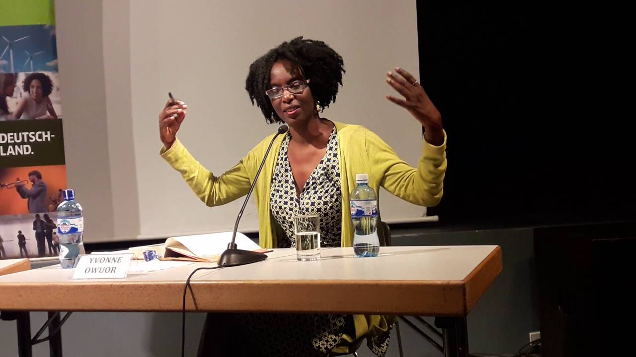

**Instructor:** Dr. Reinhold Kramer

109 Original Building/Clark Hall

727-7344 kramer@brandonu.ca

Office: 2:40-3:30 Mon, Wed

1:40-2:30 Thur

Webpages: google “Reinhold Kramer”

or <http://people.brandonu.ca/kramer/>

**Course Description:**

A study of the wide variety of writing in English outside of Europe and North America. The course will include short stories, poetry, and several novels, possibly Kiran Yvonne Owuor

Desai, *The Inheritance of Loss* (India); Yvonne Owuor,

*Dust* (Kenya); Chris Abani, *GraceLand* (Nigeria); and V. S. Naipaul, *The Mystic Masseur* (Trinidad).

Titles may change with little notice.

**Assignments:**

1. Reading tests (on *entire* novels) **16 Sept; 7 & 26 Oct; 14 Nov** 10%

2. Class Participation 10%

3. In-class Essay/Test  **5 October** 20%

4. Term Paper (10-12 pages) **Due 25 November**  20%

5. Final Exam **19 December 9-11 a.m.**  40%

There may be penalties for lateness, depending upon circumstances. Reading tests cannot be postponed and missed tests cannot be rewritten without a doctor’s note or other documentation. Cite all sources for ideas and quotations. Assignments containing plagiarism will be graded “0” and will result in disciplinary action. Please read BU UndergraduateCalendar 3.14 “Academic Integrity” and William Messenger p. 420-8. No cell phones in class.

For the very shy: in place of “class participation,” you may hand in, up to 5 times during the course, short (1-page, double-spaced, typed) analyses, not plot summaries, of a portion of the work under discussion that day. These analyses must be handed in *before* the work is discussed in class and are worth 2% each. No analyses will be accepted after class discussions for *any* reason.

Students who require disability accommodations should register with the Accessibility Services Coordinator, 204-727-9759, [magnussonm@brandonu.ca](mailto:magnussonm@brandonu.ca). Student Services also offers personal counselling (contact 204-727-9737). If students find controversial readings and/or discussions troubling, please contact the instructor immediately about alternatives.

**Grading: Letter/Number/Grade Point**

Outstanding Good Satisfactory Weak Inadequate

A+ 90 & up 4.3 B+ 77-79 3.3 C+ 67-69 2.3 D 50-59 1.0 F 0-49 0

A 85-89 4.0 B 73-76 3.0 C 63-66 2.0

A- 80-84 3.7 B- 70-72 2.7 C- 60-62 1.7

**Texts:**

Abani, Chris. *GraceLand*. 978-0312425289

Desai, Kiran. *The Inheritance of Loss*. 978-0143055716

Messenger, William, et. al. *Writing English: The Canadian Handbook* (optional). 978-0195446586

Mistry, Rohinton. *Family Matters*. 978-0771061288

Owuor, Yvonne. *Dust*.  978-0345802545

Ramraj, Victor ed. *Concert of Voices*. 2nd ed. 978-1551119779

**Tentative Schedule:**

Sept. 7 Introduction: Colonialism, the Commonwealth, Post-Colonialism

9 Walcott, “Ruins of a Great House” (1962)

12 “A Letter from Brooklyn” (1962)

14 David Dabydeen, “The New Poetry” (1988), “Catching Crabs” (1988)

Sept. 16 - 28 Owuor, *Dust* (2014)

Oct. 3 Ngugi, “Goodbye Africa” (1975)

Oct. 5 **In-class Essay/Test**

Oct. 7 - 21 Abani, *GraceLand* (2004)

Oct. 24 Achebe, “Girls at War” (1972)

Oct. 26 - Nov. 7 Mistry, Rohinton. *Family Matters* (2002)

Nov. 9 - 11 fall break – no classes

Nov. 14 - 28 Kiran Desai, *The Inheritance of Loss* (2006)

Nov. 25 **Term Paper on *GraceLand* due**

Nov. 30 Mahapatra, “The Abandoned British Cemetery at Balasore” (1979)

Anand, “Duty” (1938)

Dec. 2 Das, “An Introduction” (1965)

Anita Desai, “Surface Textures” (1978)

Dec. 5 Review

**Dec. 19 Final Exam**  **9-11 a.m. Monday**