**30.271 Film I: The Silver Screen**

Fall 2022

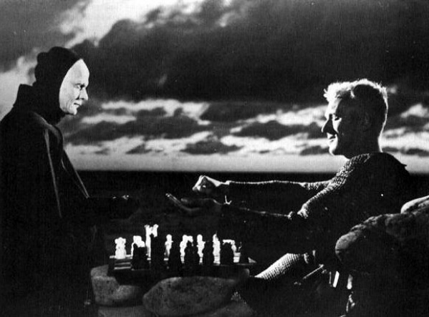

**Instructor:** Dr. Reinhold Kramer

109 Original Building/Clark Hall

727-7344 kramer@brandonu.ca

Office: 2:40-3:30 (Mon, Wed), 1:30-2:30 (Thur) Webpages: google “Reinhold Kramer”

or go to <http://people.brandonu.ca/kramer/>

**Course Description**: A study of significant 20th Century cinematic works in their social contexts. Students will learn the vocabulary of film studies and closely examine 10 or 11 films, possibly Chaplin, *Modern Times*; Renoir, *Rules of the Game*; Welles & Mankiewicz, *Citizen Kane*; Sturges, *The Lady Eve*;Reed & Greene, *The Third Man*; Zinnemann & Foreman, *High Noon*; Altman & Tewkesbury, *Nashville*;Bergman, *Autumn Sonata*; Fellini, *And the Ship Sails On*; Allen, *Hannah and her Sisters.* Films studied could change from year to year. This is not a course in filmmaking.

**Learning Outcomes**:Students will…

1. learn the analytic techniques of film studies: shot types, camera angles, point of view, camera movement, frame composition, mise-en-scène, lighting, and montage;
2. develop a critical understanding of films as aesthetic objects;
3. learn to put films from different national traditions into historical and cultural context;
4. develop writing skills by crafting analyses of particular films.

**Assignments**: 1. Class Participation 10%

2. Test **18 October**  25%

3. Term Paper (10-12 pages) **due 15 November** 25%

4. Final Exam **16 December, 2-4 p.m.**  40%

There may be penalties for lateness, depending upon circumstances. Missed tests cannot be rewritten without a doctor’s note or other documentation. Cite all sources for ideas and quotations. Assignments containing plagiarism will be graded “0” and will result in disciplinary action. Please read BU Calendar 3.14 “Academic Integrity” and Messenger p. 420-8. No cell phones in class.

For the very shy: in place of “class participation,” you may hand in, up to 5 times during the course, short (1-page, double-spaced, typed) analyses, not plot summaries, of a portion of the film under discussion that day. These analyses must be handed in *before* the film is discussed in class and are worth 2% each. No analyses will be accepted after class discussions for *any* reason.

Students who require disability accommodations should register with the Accessibility Services Coordinator, 204-727-9759, [magnussonm@brandonu.ca](mailto:magnussonm@brandonu.ca). Student Services also offers personal counselling (contact 204-727-9737). If students find controversial films and/or discussions troubling, please contact the instructor immediately about alternatives.

**Texts**:

Barsam & Monahan, *Looking at Movies*, **7th ed**. **(*new)** Videos accessed through textbook. 9780393885835

Messenger, William, et. al. *Writing English: The Canadian Handbook* (optional) 9780195446586

**Grading: Letter/Number/Grade Point**

Outstanding Good Satisfactory Weak Inadequate

A+ 90 & up 4.3 B+ 77-79 3.3 C+ 67-69 2.3 D 50-59 1.0 F 0-49 0

A 85-89 4.0 B 73-76 3.0 C 63-66 2.0

A- 80-84 3.7 B- 70-72 2.7 C- 60-62 1.7

**Tentative Schedule**

V = Video (Go to the Digital Resources webpage. Click on the chapter, then on the video. Some have very

similar names, so be sure to get the right one. Many on the syllabus are the “archived,

longer tutorials” at the bottoms of the lists.)

IT= Interactive Tutorial.

*Italicized #s* = readings/videos/ITs in both Film I & II

Sept. 13 Introduction to Cinema

20 Charlie Chaplin, *Modern Times* (1936) (1:37)

Read *Looking 8-15,* *23-31*, 45-8, *31-5*, 16-22 (*cinematic lang*, *form,* Star Wars)

339-42, 345-51, 358-62, 233-8 (classical Hollywood, history of acting)

*V: Ch 2 “Form and Content (archived, longer),”* Ch 1 “Formal Analysis: Star Wars”

27 Preston Sturges, *The Lady Eve* (1941) (1:34)

Read *Looking* *208-13, 162-7* (*frame composition*) *IT: composition*

*V: Ch 6 “Point of View (longer tutorial)”*

*Looking 158-62,* 400-6 *(lighting*, Studio System*) IT: Lighting (all 4)*

*V: Ch 5 “Lighting (archived)”*

Oct. 4 Federico Fellini, *La Strada* (1954) (1:48)

Read *Looking* *265-95, 354-7*,362-4 (*montage, Soviet montage*, neorealism) *IT: Editing*

*V: Ch 8 “Editing Techniques in Snapshot (longer)”*

*“The Evolution of Editing: Continuity… (longer)”*

*“The Evolution of Editing: Montage (longer)”*

*“The 180-Degree Rule (longer)”*

11 Jean Renoir, *La régle du jeu* (*The Rules of the Game*, 1939) (1:46)

Read *Looking* *179-82*, *193-203 (cinematography, framing, shot types)*

*V: Ch 6 “Focal Length” (archived); “Shot Types” (archived); “Camera Angles” (archived)*

*Looking 107-20*, *203-7 (narrative,* *camera movement)*

*V: Ch 6 “The Moving Camera,” “Zoom and Moving Camera Effects”*

**18** **Test;** Francis Coppola, *Apocalypse Now* (1979) (2:33)

25 *Apocalypse Now* (con’t)Read *Looking* 182-9 (colour)IT: colour grading

381-4, 406-9 (New American cinema, Independent)

Nov. 1 Carol Reed & Graham Greene, *The* *Third Man* (1949) (1:45)

Read *Looking* *145-8*, *168-76,* *213-18* (*mise-en-scène*, *POV/shot length*)

*V: Ch 5 “What is mise-en-scène?”*

*“Setting and Expressionism (longer tutorial)”*

*Looking* 351-3 (Expressionism)

8 Fred Zinnemann & Carl Foreman, *High Noon* (1952) (1:25)

Read *Looking 35-42*, 90-1 (*time*, westerns) *IT: Camera*

*V: Ch 3 “Genre: The Western (longer tutorial)”*

*Looking 127-34*, 134-43 (*duration*, *Stagecoach*)

*V: Ch 4 “Lighting and Familiar Image…”*

*“Suspense and Surprise”*

**15** **Term paper due**; Ingmar Bergman, *Höstsonaten* (*Autumn Sonata*, 1978) (1:33)

Read *Looking* *227-33, 238-40, 252-60* (*acting*)

*V: Ch 7 “Editing and Performance in Snapshot”*

22 Federico Fellini, *And the Ship Sails On* (1983) (2:07) **\*film starts at 1:00**

Read *Looking* 92-4, *121-6*, *248-52* (musicals, *diegesis*, *naturalism*)

*V: Ch 4 “Diegetic and Nondiegetic Elements”*

*V: Ch 7 “Persona and Performance”*

29 Joel & Ethan Coen, *Fargo* (1996) (1:35)

Read *Looking* 79-85, 389-400 (gangster, noir, production)

Dec. 6no class (Friday schedule)

**Dec. 16 Final exam** **2-4 p.m. Friday**