30.273 Film II: Night Visions
Winter 2023
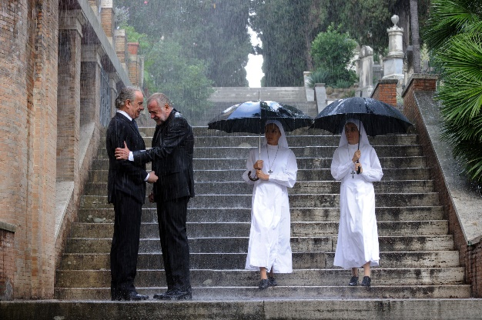
Instructor: Dr. Reinhold Kramer
109 Clark Hall 727-7344
Email: kramer@brandonu.ca
Office: Mon & Wed 2:30-3:30
Webpages: google “Reinhold Kramer”
or http://people.brandonu.ca/kramer/

Course Description: A study of significant cinematic works in their social contexts, with emphasis on the 21st Century. Students will use the vocabulary of film studies to examine 10 or 11 films, possibly Burton & Dahl, Charlie and the Chocolate Factory; Kaufman & Jonze, Being John Malkovich; Arriaga & Iñárritu, 21 Grams; Russell, I Heart Huckabees; Paolo Sorrentino, The Great Beauty; Vallée & Boulay, C.R.A.Z.Y.; Gerwig, Lady Bird; Demme & Lumet, Rachel Getting Married; Ethan & Joel Coen, A Serious Man; Zeitlin & Alibar, Beasts of the Southern Wild; Anderson, Moonrise Kingdom. Films studied could change from year to year. This is not a course in film-making.

Learning Outcomes: Students will…
- apply the rudiments of film studies – shot types, camera angles, point of view, camera movement, frame composition, mise-en-scène, lighting, and montage;
- learn to analyze the ways in which films respond to contemporary cultural forms and debates about human relationships, politics, class, religion, race, gender, and sexuality;
- develop an understanding of the relations between film rhetoric and reality; and
- develop writing skills by crafting analyses of particular films.

Assignments: 1. Class Participation 10%
2. Test Feb. 7 25%
3. Term Paper (10-12 pages) Mar. 28 25%
4. Final Exam April 18, 9-11 a.m. 40%

There may be penalties for lateness, depending upon circumstances. Missed tests cannot be rewritten without a doctor’s note or other documentation. Cite all sources for ideas and quotations. Assignments containing plagiarism will be graded “0” and will result in disciplinary action. Please read BU Undergraduate Calendar 3.14 “Academic Integrity” and William Messenger p. 420-8. No cell phones in class. No laptops, unless required through Student Accessibility Services.

For the very shy: in place of “class participation,” you may hand in, up to 5 times during the course, short (1-page, double-spaced, typed) analyses, not plot summaries, of a portion of the film under discussion that day. These analyses must be handed in before the film is discussed in class and are worth 2% each. No analyses will be accepted after class discussions for any reason.

Students who require disability accommodations should register with the Accessibility Services Coordinator, 204-727-9759, magnussonm@brandonu.ca. Student Services also offers personal counselling (contact 204-727-9737). If students find controversial films and/or discussions troubling, please contact the instructor immediately about alternatives.

Texts: Barsam & Monahan, Looking at Movies, 7th ed. Tutorials accessed via textbook.
Messenger, William, et. al. Writing English: The Canadian Handbook. (optional)

Grading: Letter/Number/Grade Point
Outstanding Good Satisfactory Weak Inadequate
A+ 90 & up 4.3 B+ 77-79 3.3 C+ 67-69 2.3 D 50-59 1.0 F 0-49
A 85-89 4.0 B 73-76 3.0 C 63-66 2.0
A- 80-84 3.7 B- 70-72 2.7 C- 60-62 1.7

Tentative Schedule
V = Video (Go to the textbook’s Digital Resources webpage. Click on the chapter, then on the video. Some have very similar names, so be sure to get the right one. Many on the syllabus are the “archived, longer tutorials” at the bottoms of the lists.)
IT= Interactive Tutorial.
Italicized #s = readings/videos/ITs in both Film I & II

Jan. 10 Introduction to contemporary cinema
17 Tim Burton & Roald Dahl, Charlie & the Chocolate Factory (2005) (1:48)
Read Looking 8-15, 23-31, 31-5, 145-8 (cinematic lang, form, mise-en-scène)
V: Ch 2 “Form and Content (archived, longer)”
Looking 148-57, 168-76 (setting, costume, mise-en-scène)
V: Ch 5 “What is mise-en-scène?”
“Setting and Expressionism (longer tutorial)”

24 Charlie Kaufman & Spike Jonze, Being John Malkovich (1999) (1:48)
Read Looking 179-82, 193-203 (cinematography, framing, shot types)
V: Ch 6 “Shot Types (archived, longer);” “Camera Angles (archived, longer)”
Looking 203-7 (camera movement)
V: Ch 6 “The Moving Camera,” “Zoom and Moving Camera Effects”
Looking 208-13, 162-7 (frame composition) IT: Composition
V: Ch 6 “Point of View (longer tutorial)”
31 Guillermo Arriaga & Alejandro Iñárritu, 21 Grams (2003) (1:58) *class starts at 1:00*
Read Looking 265-95, 35-42, 295-301 (montage, time, City of God) 2IT: Editing
V: Ch 8 “Editing Techniques in Snapshot (longer)”
“The Evolution of Editing: Continuity… (longer)”
“The Evolution of Editing: Montage (longer)”
“The 180-Degree Rule (longer)”

Feb. 7 Test; Paolo Sorrentino, La Grande Belleza (The Great Beauty, 2013) (2:21)

14 La Grande Belleza (cont); Read Looking 303-21, 325-37 (sound) IT: Sound
V: Ch 9 “Sound in Snapshot (longer, archived)”

28 Jonathan Demme & Jenny Lumet, Rachel Getting Married (2008) (1:49) *class starts
at 1:00*
Read Looking 227-33, 238-40, 248-60 (acting, naturalism, composition)
V: Ch 7 “Persona and Performance”
“Editing and Performance in Snapshot”
Looking 126-34, 369, 221-5 (duration, Dogme, Moonlight)
V: Ch 4 “Lighting and Familiar Image…”
“Suspense and Surprise”

Mar. 7 Jean-Marc Vallée & François Boulay, C.R.A.Z.Y. (2005) (2:01) *class starts at 1:00*
Read Looking 94-6, 107-26 (genre, narrative, diegesis)
V: Ch 4 “Diegetic and Nondiegetic Elements”
Looking 240-8, 260-63 (acting today, Blue Valentine)

14 Wes Anderson, Moonrise Kingdom (2012) (1:27)
Read Looking 42-5, 48-52 (Realism & Anti-, Donnie Darko)
190-3, 218-21, 364-7 (focus & lighting, special effects, New Wave)
V: Ch 6 “Focal Length (archived, longer tutorial)”

21 Benh Zeitlin & Lucy Alibar, Beasts of the Southern Wild (2012) (1:33)
Read Looking 158-62, 354-7 (lighting, Soviet montage) IT: Lighting (all 4)
V: Ch 5 “Lighting” (archived)
Looking 213-18 (POV shot, shot length)

28 Term paper due
Joel & Ethan Coen, A Serious Man (2009) (1:46)

Apr. 4 Greta Gerwig, Lady Bird (2017) (1:29)
Review

Apr. 18 Final exam, 9-11 a.m. Tuesday

