**30.145 Contemporary Literature**

Fall 2024

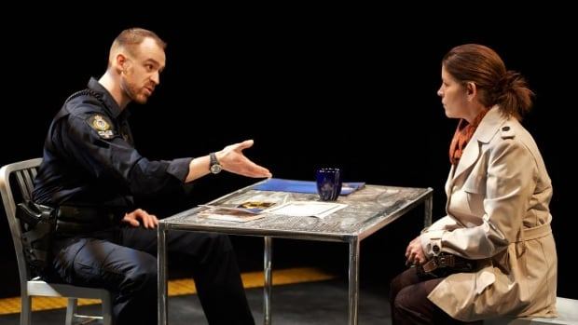

**Instructor**: Dr. Reinhold Kramer

109 Clark Hall 727-7344 [kramer@brandonu.ca](mailto:kramer@brandonu.ca)

Office hours: 1:40-2:30 Mon, Wed

Home page: google “Reinhold Kramer”

or <http://people.brandonu.ca/kramer/>

**Course Description:** This survey introduces students to a rich variety of fiction, poetry, and drama in English. Each section of the course is unique, is designed for student to learn the vocabulary of literary studies, and may focus on a particular nation or cultural theme. We will emphasize writing skills, with at least three essay assignments, and students will receive help, wherever needed, in planning, developing, and writing effective essays.

**The Valley (Prairie Theatre Exchange)**

**Learning Outcomes**:Students will…

1. learn how to analyze literature by studying representation, symbolism, point of view, narrative structure, genre, realism, parody, irony, and various aspects of poetic form;
2. learn how fiction works as an empathy technology, addressing specific human existential concerns, social attitudes, political positions, and spiritual hopes in the contemporary world;
3. develop grammatical knowledge by studying sentence structure and grammatical errors; and
4. develop writing skills by studying basic essay structure and by writing essays.

**Assignments:**  1. Reading tests (on entire novels) **25 September, 18 November**  10%

2. Class Participation 5%

3. In-class Essay (5 pages) **20 September**  10%

4. Atwood Essay (5 pages) **due 18 October**  15%

5. Poetry Essay (5 pages) **due 8 November**  15%

6. Grammar test **25 November**  10%

7. Final Exam **10 Dec., 9-11 a.m.**  35%

There may be penalties for late essays, depending upon circumstances. Reading tests cannot be postponed, and missed tests cannot be rewritten without a doctor’s note or other documentation. Cite all sources for ideas and quotations. Assignments containing plagiarism (including uncited AI content) will be graded “0” and result in disciplinary action. Please read BU *General Calendar* section 3.15 “Academic Integrity,” and *Writing English*, p. 420-8. No cellphones during class.

For the very shy: in place of “class participation,” you may hand in, 5 times during the course, short (1-page, double-spaced, typed) analyses, not plot summaries, of the work under discussion that day. These commentaries must be handed in *before* the work is discussed in class and are worth 1% each. No commentaries will be accepted after class discussions for *any* reason.

Students who require disability accommodations should register with the Accessibility Services (204-727-9759, [magnussonm@brandonu.ca](mailto:magnussonm@brandonu.ca)). BU also offers personal counselling (204-727-9737) and sexual violence support (431-542-1707). If students find controversial readings and/or discussions troubling, please contact the instructor immediately about alternatives.

**Texts:**

Bennett, Donna & Russell Brown. *An Anthology of Canadian Literature in English.* **4th ed**.

Coupland, Douglas. *Generation A* (2009)

MacLeod, Joan. *The Valley* (2014)

Mandel, Emily. *The Glass Hotel* (2020)

Messenger, William, et. al. *Writing English: The Canadian Handbook*

**Grading: Letter/Number/Grade Point**

Outstanding Good Satisfactory Weak Inadequate

A+ 90 & up 4.3 B+ 77-79 3.3 C+ 67-69 2.3 D 50-59 1.0 F 0-49

A 84-89 4.0 B 74-76 3.0 C 64-66 2.0

A- 80-83 3.7 B- 70-73 2.7 C- 60-63 1.7

**Tentative Schedule:** **simultaneous** ***Writing English*** **readings [below]**

Sept. 6 Leacock, “The Marine Excursion of the Knights…” (1912) *Writing English* 406-11

9 Pickthall, “The Third Generation” (1922)

11 Wilson, “The Window” (1961) *Writing English* 382-4

13 Laurence, “To Set Our House in Order” (1963, 1970) *Writing English* 384-6

16 Atwood, “The Age of Lead” (1991)

18 Vanderhaeghe, “Man on Horseback” (1992) *Writing English* 174 Tense

**20** **In-class essay**

23Robinson, “Queen of the North” (1996)

Sept. 25 - Oct. 11 Coupland, *Generation A* (2009) *Writing English* 402-4; 420-8; 388-9; 286-8; 435-43

Sept. 30 no class: National Day for Truth and Reconciliation

Oct. 16 John K. Samson (Weakerthans), “Pamphleteer” (2000) Internet Christine Fellows, “Regrets” (2002) Internet

**17 “Make-up Monday”**(Monday classes scheduled) *Writing English* 97-8, 110-11

A.M. Klein, “Heirloom” (1940)

Birney, “El Greco: Espolio” (1960)

**18** **Coupland essay due**

Reaney, “The School Globe” (1949) “The Lost Child” (1962)

21 Lee, “Civil Elegies 1” (1968, 1972, 2017) *Writing English* 34-5; 62-7; 7-15

23 Atwood, “Progressive Insanities of a Pioneer” (1968)

25 Kroetsch, *Seed Catalogue* 1, 9 (1977) *Writing English* 38-44; 126-7

28 Mouré, “Miss Chatelaine” (1988), “Blindness” (1985)

30 McKay, “Pond” (2006) *Writing English* 130-5; 14-17, 27-9

Lane, “The Sooke Potholes” (2007)

Nov. 1Crozier, “Poem About Nothing” (1985)

Nov. 4 - 8 MacLeod, *The Valley* (2014) *Writing English* 90-4; 52-5, 175

**Nov. 8 Poetry essay due**

Nov. 11-15 FallBreak: no classes

Nov. 18 - 29 Mandel, *The Glass Hotel* (2020) *Writing English* 58-62; 167-73; 173-4

**Nov. 25** **Grammar test**

Dec. 2 Karen Solie, “Tractor” (2009), “Your Premiums Will Never Increase” (2005)

4 Review

**Dec. 10 Final Exam Tues., 9-11 a.m.**