30.271 Film I: The Silver Screen
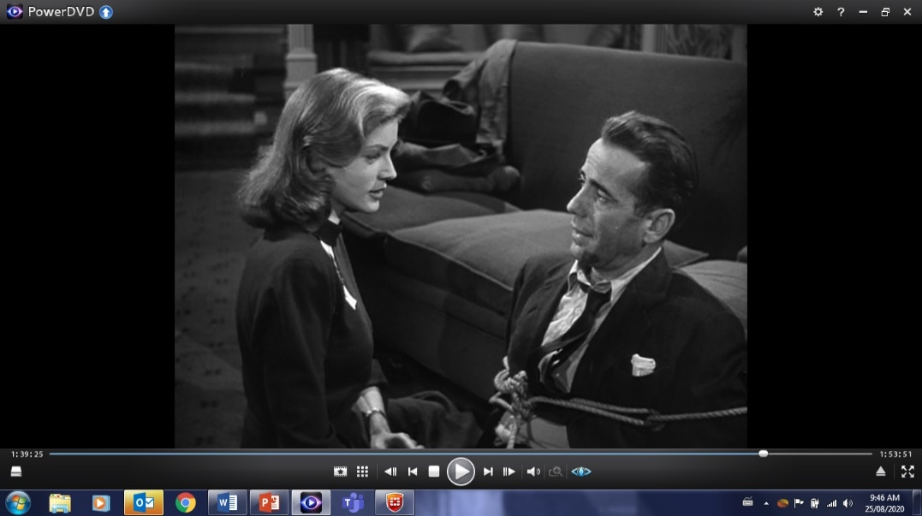
Fall 2024

Instructor: Dr. Reinhold Kramer
109 Original Building/Clark Hall
727-7344 kramer@brandonu.ca
Office hours: 1:40-2:30 Mon, Wed Webpages: google “Reinhold Kramer” or
http://people.brandonu.ca/kramer/

Course Description: A study of significant 20th Century cinematic works in their social contexts. Students will learn the vocabulary of film studies and closely examine 10 or 11 films, possibly Chaplin, Modern Times; Renoir, Rules of the Game; Welles & Mankiewicz, Citizen Kane; Sturges, The Lady Eve; Reed & Greene, The Third Man; Zinnemann & Foreman, High Noon; Altman & Tewkesbury, Nashville; Bergman, Autumn Sonata; Fellini, And the Ship Sails On; Allen, Hannah and her Sisters. Films studied could change from year to year. This is not a course in filmmaking.

Learning Outcomes: Students will…
- learn the analytic techniques of film studies: shot types, camera angles, point of view, camera movement, frame composition, mise-en-scène, lighting, and montage;
- develop a critical understanding of films as aesthetic objects;
- learn to put films from different national traditions into historical and cultural context;
- develop writing skills by crafting analyses of particular films.

Assignments: 1. Class Participation 10%
2. Test 15 October 25%
3. Term Paper (8 pages) due 19 November 25%
4. Final Exam 17 December, 9-11 a.m. 40%

There may be penalties for late essays, depending upon circumstances. Cite all sources for ideas and quotations. Assignments containing plagiarism (including uncited AI content) will be graded “0” and result in disciplinary action. Please read BU General Calendar section 3.15 “Academic Integrity,” and Writing English, p. 420-8. No cellphones during class.

For the very shy: in place of “class participation,” you may hand in, 5 times during the course, short (1-page, double-spaced, typed) analyses, not plot summaries, of the work under discussion that day. These commentaries must be handed in before the work is discussed in class and are worth 1% each. No commentaries will be accepted after class discussions for any reason.

Students who require disability accommodations should register with the Accessibility Services (204-727-9759, magnussonm@brandonu.ca). BU also offers personal counselling (204-727-9737) and sexual violence support (431-542-1707). If students find controversial readings and/or discussions troubling, please contact the instructor immediately about alternatives.

Texts:
Barsam & Monahan, Looking at Movies, 7th ed. Tutorials accessed through textbook. 9780393674699
Messenger, William, et. al. Writing English: The Canadian Handbook (optional) 9780195446586

Grading: Letter/Number/Grade Point
Outstanding Good Satisfactory Weak Inadequate
A+ 90 & up 4.3 B+ 77-79 3.3 C+ 67-69 2.3 D 50-59 1.0 F 0-49 0
A 85-89 4.0 B 73-76 3.0 C 63-66 2.0
A- 80-84 3.7 B- 70-72 2.7 C- 60-62 1.7

Tentative Schedule
V = Video (Go to the Digital Resources webpage. Click on the chapter, then on the video. Some have very
similar names, so be sure to get the right one. Many on the syllabus are the “archived,
longer tutorials” at the bottoms of the lists.)
IT= Interactive Tutorial.
Italicized #s = readings/videos/ITs in both Film I & II

Sept. 10 Introduction to Cinema
17 Charlie Chaplin, Modern Times (1936) (1:37)
Read Looking 8-15, 23-31, 45-8, 31-5, 16-22 (cinematic lang, form, Star Wars)
339-42, 345-51, 358-62, 233-8 (classical Hollywood, history of acting)
V: Ch 2 “Form and Content (archived, longer),” Ch 1 “Formal Analysis: Star Wars”
24 Preston Sturges, The Lady Eve (1941) (1:34)
Looking 158-62, 213-18, 400-6 (lighting, POV/shot length Studio System)
IT: Lighting (all 4)
V: Ch 5 “Lighting (archived)”
V: Ch 6 “Point of View (longer tutorial)”

Oct. 1 Howard Hawks, The Big Sleep (1946) (1:54) *film starts @ 1:00*
Read Looking 208-13, 162-7, 145-8, 168-76 (frame composition, mise-en-scène)
79-85 (gangster & noir) IT: composition
V: Ch 5 “What is mise-en-scène?”
“Setting and Expressionism (longer tutorial)”

8 Federico Fellini, La Strada (1954) (1:48)
Read Looking 265-95, 354-7, 362-4 (montage, Soviet montage, neorealism)
IT: Editing
V: Ch 8 “Editing Techniques in Snapshot (longer)”
“The Evolution of Editing: Continuity… (longer)”
“The Evolution of Editing: Montage (longer)”
“The 180-Degree Rule (longer)”

15 Test; Francis Coppola, Apocalypse Now (1979) (2:33)

22 Apocalypse Now (con’t) Read Looking 182-9 (colour) IT: colour grading
381-4, 406-9 (New American cinema, Independent)

29 Jean Renoir, La régle du jeu (The Rules of the Game, 1939) (1:46)
Read Looking 179-82, 193-203 (cinematography, framing, shot types)
V: Ch 6 “Focal Length” (archived); “Shot Types” (archived); “Camera Angles” (archived)
Looking 107-20, 203-7 (narrative, camera movement)
V: Ch 6 “The Moving Camera,” “Zoom and Moving Camera Effects”

Nov. 5 Carol Reed & Graham Greene, The Third Man (1949) (1:45)
Read Looking 35-42, 127-34, 351-3 (time, duration, familiar image, Expressionism)
IT: Camera
V: Ch 4 “Lighting and Familiar Image…”
“Suspense and Surprise”

19 Term paper due; Ingmar Bergman, Höstsonaten (Autumn Sonata, 1978) (1:33)
Read Looking 227-33, 238-40, 252-60 (acting)
V: Ch 7 “Editing and Performance in Snapshot”

26 Federico Fellini, And the Ship Sails On (1983) (2:07) *film starts at 1:00
Read Looking 92-4, 121-6, 248-52 (musicals, diegesis, naturalism)
389-400 (production)
V: Ch 4 “Diegetic and Nondiegetic Elements”
V: Ch 7 “Persona and Performance”

Dec. 3 Joel & Ethan Coen, Fargo (1996) (1:35)

Dec. 17 Final exam 9-11 a.m. Tuesday

