30.387 Alternate Worlds
Fall 2024
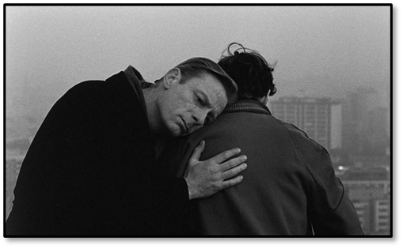
Instructor: Dr. Reinhold Kramer
109 Original Building/Clark Hall
727-7344 kramer@brandonu.ca
Office: 1:40-2:30 p.m. Mon, Wed
Webpages: google “Reinhold Kramer” or
http://people.brandonu.ca/kramer/

Course Description: We will examine a rich series of ‘scenario-spinning’ works, in which authors create worlds that are neither completely fantastic nor fully representative of our own world. Fiction to be studied scene from Wings of Desire (1987)
could include Mitchell, Cloud Atlas; McCarthy, The Road;
Chabon, The Yiddish Policemen’s Union; Vonarburg, The Maerlande Chronicles. Films could include Wenders & Handke, Wings of Desire (Der Himmel über Berlin) and Jeunet & Laurant, Amélie (Le Fabuleux destin d’Amélie Poulain). Titles may change with little notice.

Learning Outcomes: Students will…
- learn the analytic techniques of literary and film studies: for example, symbolic representation, point of view, narrative form, camera angles, frame composition, and montage;
- develop an understanding of various modes of counterfactual speculation and how they diverge from realism;
- learn to critically analyze how counterfactual speculation comments directly or indirectly on the existential, social, political, and spiritual aspects of the contemporary world; and
- develop writing skills by crafting analyses of particular works of literature and film.

Assignments:
1. Class Participation 10%
2. Reading Tests Sept. 9; Oct. 4, 16, 28, Nov. 25 10%
3 Mid-term Test 11 October 20%
4. Essay (10-12 pages) 22 November 20%
5. Final Exam 11 December 2-4 p.m. 40%

There may be penalties for lateness, depending upon circumstances. Reading tests cannot be postponed, and missed tests cannot be rewritten without a doctor’s note or other documentation. Reading tests cover the entire novel. The exception is Cloud Atlas (for which the first reading test covers pp. 1-236 and the second test pp. 237-509).

Cite all sources for ideas and quotations. Assignments containing plagiarism (including uncited AI content) will be graded “0” and result in disciplinary action. Please read BU General Calendar section 3.15 “Academic Integrity,” and Writing English, p. 420-8. No cellphones during class.

For the very shy: in place of “class participation,” you may hand in, 5 times during the course, short (1-page, double-spaced, typed) analyses, not plot summaries, of the work under discussion that day. These commentaries must be handed in before the work is discussed in class and are worth 1% each. No commentaries will be accepted after class discussions for any reason.

Students who require disability accommodations should register with the Accessibility Services (204-727-9759, magnussonm@brandonu.ca). BU also offers personal counselling (204-727-9737) and sexual violence support (431-542-1707). If students find controversial readings and/or discussions troubling, please contact the instructor immediately about alternatives.

Grading: Letter/Number/Grade Point
Outstanding Good Satisfactory Weak Inadequate
A+ 90 & up 4.3 B+ 77-79 3.3 C+ 67-69 2.3 D 50-59 1.0 F 0-49 0
A 85-89 4.0 B 73-76 3.0 C 63-66 2.0
A- 80-84 3.7 B- 70-72 2.7 C- 60-62 1.7

Texts:
Chabon, Michael. The Yiddish Policemen’s Union, HarperCollins, 2007.
Krueger, Lesley. Time Squared, ECW Press, 2021.
McCarthy, Cormac. The Road, Vintage (Random House), 2006.
Messenger, William, et. al. Writing English: The Canadian Handbook, Oxford UP, 2012. (optional)
Mitchell, David. Cloud Atlas, Vintage (Random House), 2004.

Schedule:
Sept. 4, 6 Introduction
Sept. 9 - 20 Lesley Krueger, Time Squared

Sept. 23 - Oct. 2 Wim Wenders & Peter Handke, Wings of Desire
(Der Himmel über Berlin; 1987) (2:08)
*Sept. 23rd class is in CH 215 from 2:30 – 4:40 to view film

Oct. 4 - 9 Mitchell, Cloud Atlas (2004)
Oct. 2 Reading test, pp. 1-236
Oct. 11 Mid-term Test
Oct. 16, 17 - 25 Mitchell, Cloud Atlas
Oct. 16 Reading test, pp. 237-509
(includes Oct 17th “Makeup Monday” with Monday classes scheduled)

Oct. 28 - Nov. 8 Chabon, The Yiddish Policemen’s Union (2007)
Nov. 11-15 Study break (no class)

Nov. 18 - 22 Jean-Pierre Jeunet & Guillaume Laurant, Amélie
(Le fabuleux destin d’Amélie Poulain; 2001) (2:02)
*Nov. 18th class is in CH 215 from 2:30 – 4:40 to view film
Nov. 22 Essay due
Nov. 25 - Dec. 4 McCarthy, The Road (2006); Review

Dec. 11 Final Exam, Wednesday, 2-4 p.m.

