30.273 Film II: Night Visions
Fall 2025
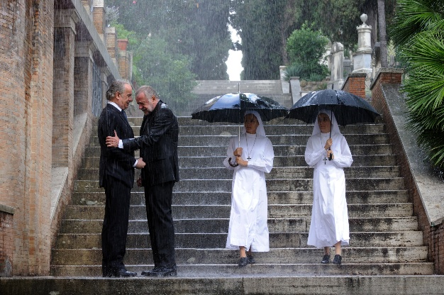
Instructor: Dr. Reinhold Kramer
109 Clark Hall 727-7344
Email: kramer@brandonu.ca
Office: Mon/Wed 1:30-2:30
Webpages: google “Reinhold Kramer”
or http://people.brandonu.ca/kramer/

Course Description: A study of significant cinematic works in their social contexts, with emphasis on the 21st Century. Students will use the vocabulary of film studies to examine 10 or 11 films, possibly Burton & Dahl, Charlie and the Chocolate Factory; Kaufman & Jonze, Being John Malkovich; Arriaga & Iñárritu, 21 Grams; Russell, I Heart Huckabees; Paolo Sorrentino, The Great Beauty; Vallée & Boulay, C.R.A.Z.Y.; Gerwig, Lady Bird; Demme & Lumet, Rachel Getting Married; Ethan & Joel Coen, A Serious Man; Zeitlin & Alibar, Beasts of the Southern Wild; Anderson, Moonrise Kingdom. Films studied could change from year to year. This is not a course in film-making.

Learning Outcomes: Students will…
- apply the rudiments of film studies – shot types, camera angles, point of view, camera movement, frame composition, mise-en-scène, lighting, and montage;
- learn to analyze the ways in which films respond to contemporary cultural forms and debates about human relationships, politics, class, religion, race, gender, and sexuality;
- develop an understanding of the relations between film rhetoric and reality; and
- develop writing skills by crafting analyses of particular films.

Assignments: 1. Class Participation 10%
2. Test October 7 25%
3. Term Paper (8 pages) December 2 25%
4. Final Exam December 12, 9-11 a.m. 40%

There may be penalties for late essays, depending upon circumstances. Cite all sources for ideas and quotations. Assignments containing plagiarism (including uncited AI content) will be graded “0” and result in disciplinary action. Please read BU General Calendar section 3.15 “Academic Integrity,” and Writing English, p. 420-8. No cellphones during class.

For the very shy: in place of “class participation,” you may hand in, 5 times during the course, short (1-page, double-spaced, typed) analyses, not plot summaries, of the work under discussion that day. These commentaries must be handed in before the work is discussed in class and are worth 2% each. No commentaries will be accepted after class discussions for any reason.

Students who require disability accommodations should register with the Accessibility Services (204-727-9759, magnussonm@brandonu.ca). BU also offers personal counselling (204-727-9737) and sexual violence support (431-542-1707). If students find controversial films and/or discussions troubling, please contact the instructor immediately about alternatives.

Texts: Barsam & Monahan, Looking at Movies, 8th ed. Tutorials accessed via textbook.
Messenger, William, et. al. Writing English: The Canadian Handbook. (optional)

Grading: Letter/Number/Grade Point
Outstanding Good Satisfactory Weak Inadequate
A+ 90 & up 4.3 B+ 77-79 3.3 C+ 67-69 2.3 D 50-59 1.0 F 0-49
A 85-89 4.0 B 73-76 3.0 C 63-66 2.0
A- 80-84 3.7 B- 70-72 2.7 C- 60-62 1.7

Tentative Schedule
V = Video (Go to the textbook’s Digital Resources webpage. Click on the chapter, then on the video. Some have very similar names, so be sure to get the right one. Many on our syllabus are the “longer tutorials” at the bottoms of the lists.)
IT= Interactive Tutorial.
Italicized #s = readings/videos/ITs in both Film I & II

Sept. 9 Introduction to contemporary cinema
16 Charlie Kaufman & Spike Jonze, Being John Malkovich (1999) (1:48)
Read Looking 8-15, 23-30, 30-33, 135-8 (cinematic lang, form, mise-en-scène)
V: Ch 2 “Form and Content (archived, longer tutorial)”
Looking 138-46, 157-66 (setting, costume, mise-en-scène)
V: Ch 6 “What is mise-en-scène?”

23 Joel & Ethan Coen, A Serious Man (2009) (1:46)
Read Looking 167-70, 182-90 (cinematography, framing, shot types)
V: Ch 7 “Shot Types (archived, longer…)”
“Camera Angles (archived, longer…)”
Looking 190-6 (camera movement)
V: Ch 7 “The Moving Camera,”
“Zoom and Moving Camera Effects”
Looking 196-8, 151-7 (frame composition) IT: Composition
V: Ch 7 “Point of View (longer…)”

30 No Class: National Day for Truth and Reconciliation

Oct. 7 Guillermo Arriaga & Alejandro Iñárritu, 21 Grams (2003) (1:58) *class starts at 1:00*
Read Looking 243-70, 33-40, 270-6 (montage, time, City of God) 2IT: Editing
V: Ch 9 “Editing Techniques in Snapshot (longer…)”
“The Evolution of Editing: Continuity and Classical Cutting (longer…)”
“The Evolution of Editing: Montage (longer…)”
“The 180-Degree Rule (longer…)”

14 Jonathan Demme & Jenny Lumet, Rachel Getting Married (2008) (1:49) *class starts
at 1:00*
Read Looking 213-19, 224-8, 249-38 (acting, naturalism, composition)
V: Ch 8 “Persona and Performance” (longer…)
“Editing and Performance in Snapshot” (longer…)
Looking 119-28, 347-8, 209-12 (duration, Dogme, Moonlight)
V: Ch 5 “Lighting and Familiar Image in The Night of the Hunter (longer…)”

Oct. 21 Test; Paolo Sorrentino, La Grande Belleza (The Great Beauty, 2013) (2:21)

28 La Grande Belleza (cont); Read Looking 277-94, 294-305 (sound) IT: Sound
V: Ch 10 “Sound in Snapshot (longer, archived…)”

Nov. 4 Jean-Marc Vallée & François Boulay, C.R.A.Z.Y. (2005) (2:01) *class starts at 1:00*
Read Looking 97-9, 103-19 (genre, narrative, diegesis)
V: Ch 5 “Diegetic and Nondiegetic Elements” (longer…)
Looking 225-36, 238-42 (acting, Blue Valentine)

18 Wes Anderson, Moonrise Kingdom (2012) (1:27)
Read Looking 40-43, 45-9 (Realism & Anti-, Donnie Darko)
178-82, 198-205, 335-8 (focus & lighting, special effects, New Wave)
V: Ch 7 “Focal Length (archived, longer…)”

25 Benh Zeitlin & Lucy Alibar, Beasts of the Southern Wild (2012) (1:33)
Read Looking 146-51, 321-5 (lighting, Soviet montage) IT: Lighting (all 4)
V: Ch 6 “Lighting” (archived, longer…)
Looking 198-205 (POV shot, shot length)

Dec. 2 Term paper due
Greta Gerwig, Lady Bird (2017) (1:29)

5 Lulu Wang, The Farewell (2019) (1:33) (Dec. 5 follows the Tuesday slot schedule)
Review

Dec. 12 Final exam, 9-11 a.m. Friday

