30.478 Postmodernism and Beyond
Fall 2026

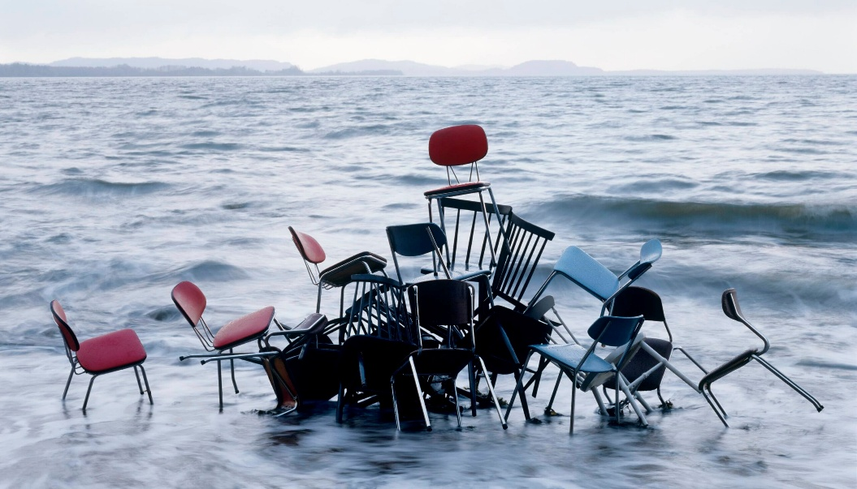
Instructor: Dr. Reinhold Kramer
Rune Guneriussen, “Twenty-four seven, #21” (2006)
109 Clark Hall, 204-727-7344
kramer@brandonu.ca
Office: 2:40-3:30 Mon, Wed
Webpages: google “Reinhold Kramer” or
http://people.brandonu.ca/kramer/

Course Description: We will examine
late 20th-century and early 21st-century literature and film, focusing on how artistic works and human emotions respond to new media environments, to scientific advances, and to a culture of simulation. Films could include Wes Anderson, The Royal Tenenbaums, Kaufman & Jonze, Adaptation. Fiction could include Stoppard, The Real Inspector Hound; Wallace, The Suffering Channel; Shteyngart, Super Sad True Love Story; Powers, Generosity; and Egan, A Visit from the Goon Squad; Theis, If Sylvie Had Nine Lives. Titles may change with little notice.

Assignments: 1. Class Participation 10%
2. Reading Tests 25 Sept.; 19 Oct.; 2, 30 Nov. 10%
3. Mid-term test 16 Oct. 20%
4. Seminar presentation & responses (various dates) 10%
5. Essay (12-14 pages) 23 Nov. (later for Anderson or Powers) 20%
6. Final Exam 18 December, 9-11 a.m. 30%

There may be penalties for late essays, depending upon circumstances. Reading tests cannot be postponed, and missed tests cannot be rewritten without a doctor’s note or other documentation. Cite all sources for ideas and quotations. Assignments containing plagiarism (including uncited AI content) will be graded “0” and result in disciplinary action. Please read BU General Calendar section 3.15 “Academic Integrity,” and Writing English, p. 420-8. No cellphones during class.

Students who require disability accommodations should register with the Accessibility Services (204-727-9759, magnussonm@brandonu.ca). BU also offers personal counselling (204-727-9737) and sexual violence support (431-542-1707). If students find controversial readings and/or discussions troubling, please contact the instructor immediately about alternatives.

Grading: Letter/Number/Grade Point
Outstanding Good Satisfactory Weak Inadequate
A+ 90 & up 4.3 B+ 77-79 3.3 C+ 67-69 2.3 D 50-59 1.0 F 0-49 0
A 85-89 4.0 B 73-76 3.0 C 63-66 2.0
A- 80-84 3.7 B- 70-72 2.7 C- 60-62 1.7

Texts: *please use paper copies of texts (you’ll need correct page numbers in class)
Egan, Jennifer. A Visit from the Goon Squad 978-0307477477
Powers, Richard. Generosity 978-0312429751
Shteyngart, Gary. Super Sad True Love Story 978-0812977868
Stoppard, Tom. The Real Inspector Hound 978-0802135612
Theis, Leona. If Sylvie Had Nine Lives 978-1988298719

Tentative Schedule:
Sept. 9 - 11 approaches to postmodernity
Sept. 14 - 16 Tom Stoppard, The Real Inspector Hound (1968)
Sept. 16 choose seminar topics & response

Self-reflexive irony or post-irony?
Sept. 18 - 23 Charlie Kaufman, Adaptation (2002) (1:50) (sexual & violent content)
(Note: 18 Sept. class will run from 1:40 - 3:30 for viewing the film.)

Postmodernity and the Social Order
Sept. 25 - Oct. 14 Gary Shteyngart, Super Sad True Love Story (2010) (sexual content)

Sept 30 National Day for Truth and Reconciliation (no class)
Oct. 12 Thanksgiving (no class)
Oct. 16 Mid-term Test

Media Simulacra
Oct. 19 - 30 Jennifer Egan, A Visit from the Goon Squad (2010)
critiques of postmodernity

Chance vs. Order, The Nature of the Self
Nov. 2 - 20 Leona Theis, If Sylvie Had Nine Lives (2020)
Nov. 9 - 13 Fall Break: no classes

Parody vs. Character
Nov. 23 Essay Due
Nov. 23 - 27 Wes Anderson, The Royal Tenenbaums (2001) (1:50) (suicide content)
(Note: 23 Nov. class will run from 1:40 - 3:30 for viewing the film.)

After Postmodernism?
Nov. 30 - Dec. 10 Richard Powers, Generosity (2009)
(Note: Thursday, Dec. 10 follows the Monday slot schedule)
Dec. 11 Review
Dec. 18 Final Exam Fri., 9-11 a.m.
Seminar Presentations
By 16 Sept. choose one work on which to present & one work to respond to.
You will present on the first day that we study the work.
Your seminar presentation can become the basis of your research paper if you wish.
Responders should be prepared to ask 2 questions directly related to the topic presented.

Length: 5 minutes (prepare slightly more material than needed; plan cuts to meet the time limit)

Topic: --in relation to the topic, explain the writer’s approach, thematic elements, and style(s)
--explain how the work is postmodern (either stylistically or in its depiction of society)
--no biographies, please
--use lecture style (don’t read your paper); you’re welcome to use PowerPoint

Topic suggestions: (you may choose different topics, but please clear them with me first)
Undermining Realism or Undermining the Detective Story in The Real Inspector Hound
Truth or the Self or Filmic Technique in Adaptation
Individualism or Love/Relationships or Social Media or the Nation in Super Sad True Love Story
Media Manipulation or the Shifting Self or Music or Time in A Visit from the Goon Squad
The Nature of the Self or The Role of Chance in If Sylvie Had Nine Lives
Character or Genre or Filmic Technique in The Royal Tennenbaums
Genetic Manipulation or Media or the Narrator in Generosity

Research: --use at least one of the works in the Bibliography below
--use secondary sources on the works or on the authors, if available
--if you can’t find secondary sources, use a 2nd work from the Bibliography below
--just before the presentation, give me a sheet containing your main points and references

General Bibliography:
Baudrillard, Jean. Selected Writings, 2nd ed., 2001.
Bauman, Zygmunt. Liquid Modernities, 2000.
___. Postmodernity and its Discontents., 1997.
___. Postmodern Ethics, 1993.
Boggs, Carl & Tom Pollard. A World in Chaos: Social Crisis and the Rise of Postmodern Cinema, 2003.
Booker, M. Keith. Postmodern Hollywood, 2007.
Butler, Christopher. Postmodernism: A Very Short Introduction, 2002.
Gregson, Ian. Postmodern Literature, 2004.
Hutcheon, Linda. A Poetics of Postmodernism: History, Theory, Fiction, 1988.
Kirby, Alan. Digimodernism, 2009.
Kramer, Reinhold. Are We Postmodern Yet? And Were We Ever? 2019.
Lipovetsky, Gilles. Hypermodern Times, 2005.
McHale, Brian. Pöstmodernist Fictiön, 1987.
___. The Cambridge Introduction to Postmodernism, 2015.
Pinker, Steven. Enlightenment Now, 2018. (Ch. 20 “The Future of Progress” & Ch.21 “Reason”)
Sim, Stuart. ed. The Routledge Companion to Postmodernism. 3rd ed., 2011.
Timmer, Nicoline. Do You Feel It Too? The Post-Postmodern Syndrome in American Fiction, 2010.

